**Muhammad Sadeeq Contribution as a 3D Artist**

As the 3D Artist, I was responsible for creating various models essential to the game. These models were designed, textured, and optimized for performance in Unity. Below are the key models I created:

**1. Environment Assets**

* **Walls:** Designed low-poly walls with textures to create an immersive game world.
* **Props:** Created objects such as table, chairs, doors, and lamp to enhance the game environment.
* **Terrain Features:** Modeled, trees, and grass to add realism to outdoor areas.

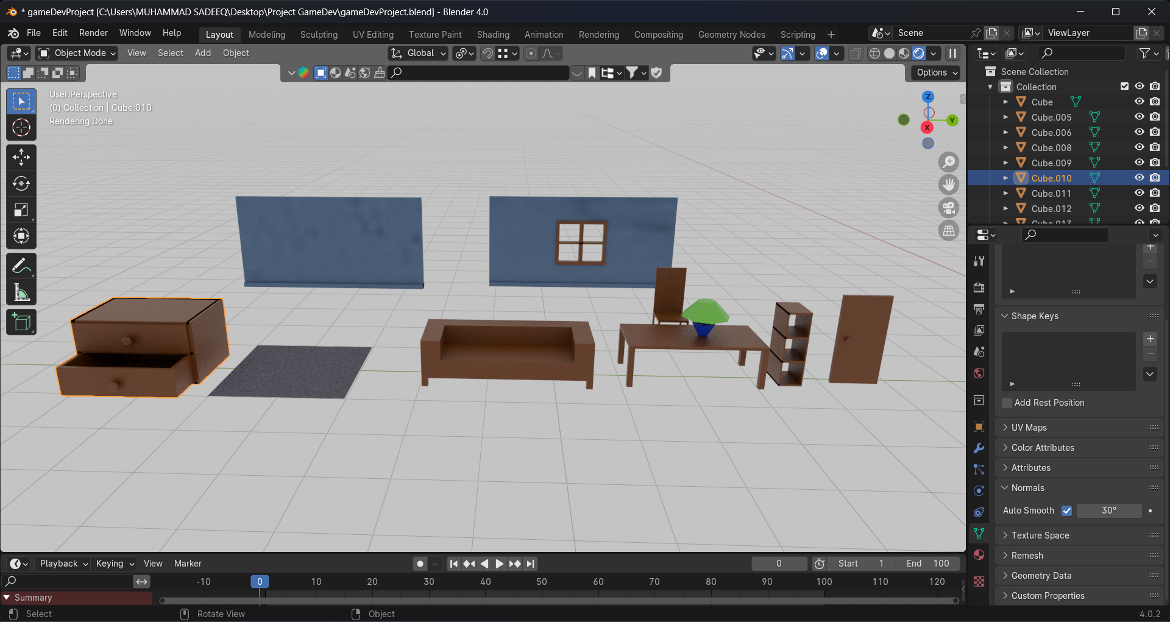

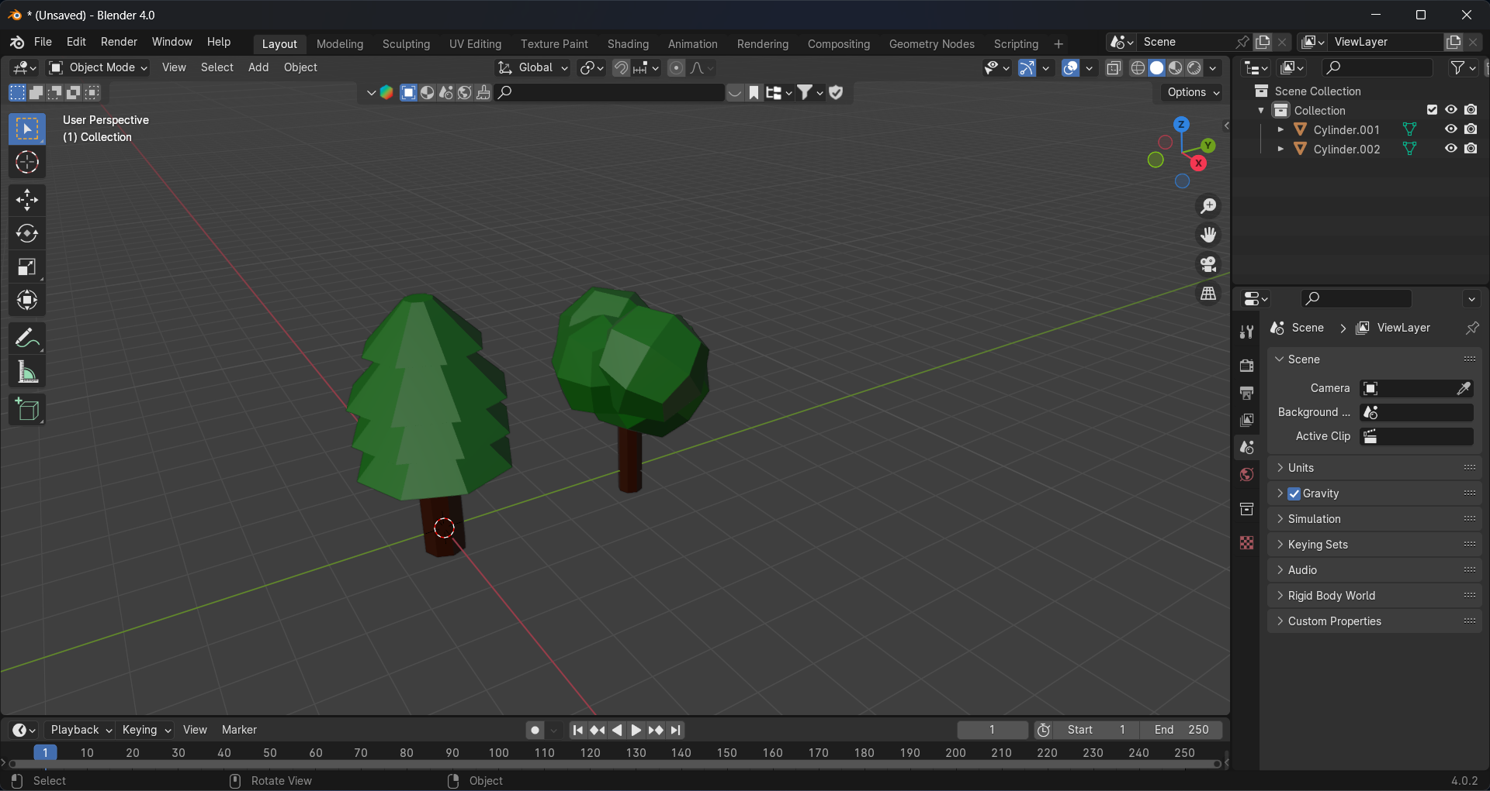

**2. Character Models**

* **Main Character:** Downloaded a 3D model for playable character, fixing and optimization of it mesh, ensuring proper rigging and animation compatibility.
* **NPCs (Non-Playable Characters):** Created enemy NPC from the main character by making changes in it mesh and materials.

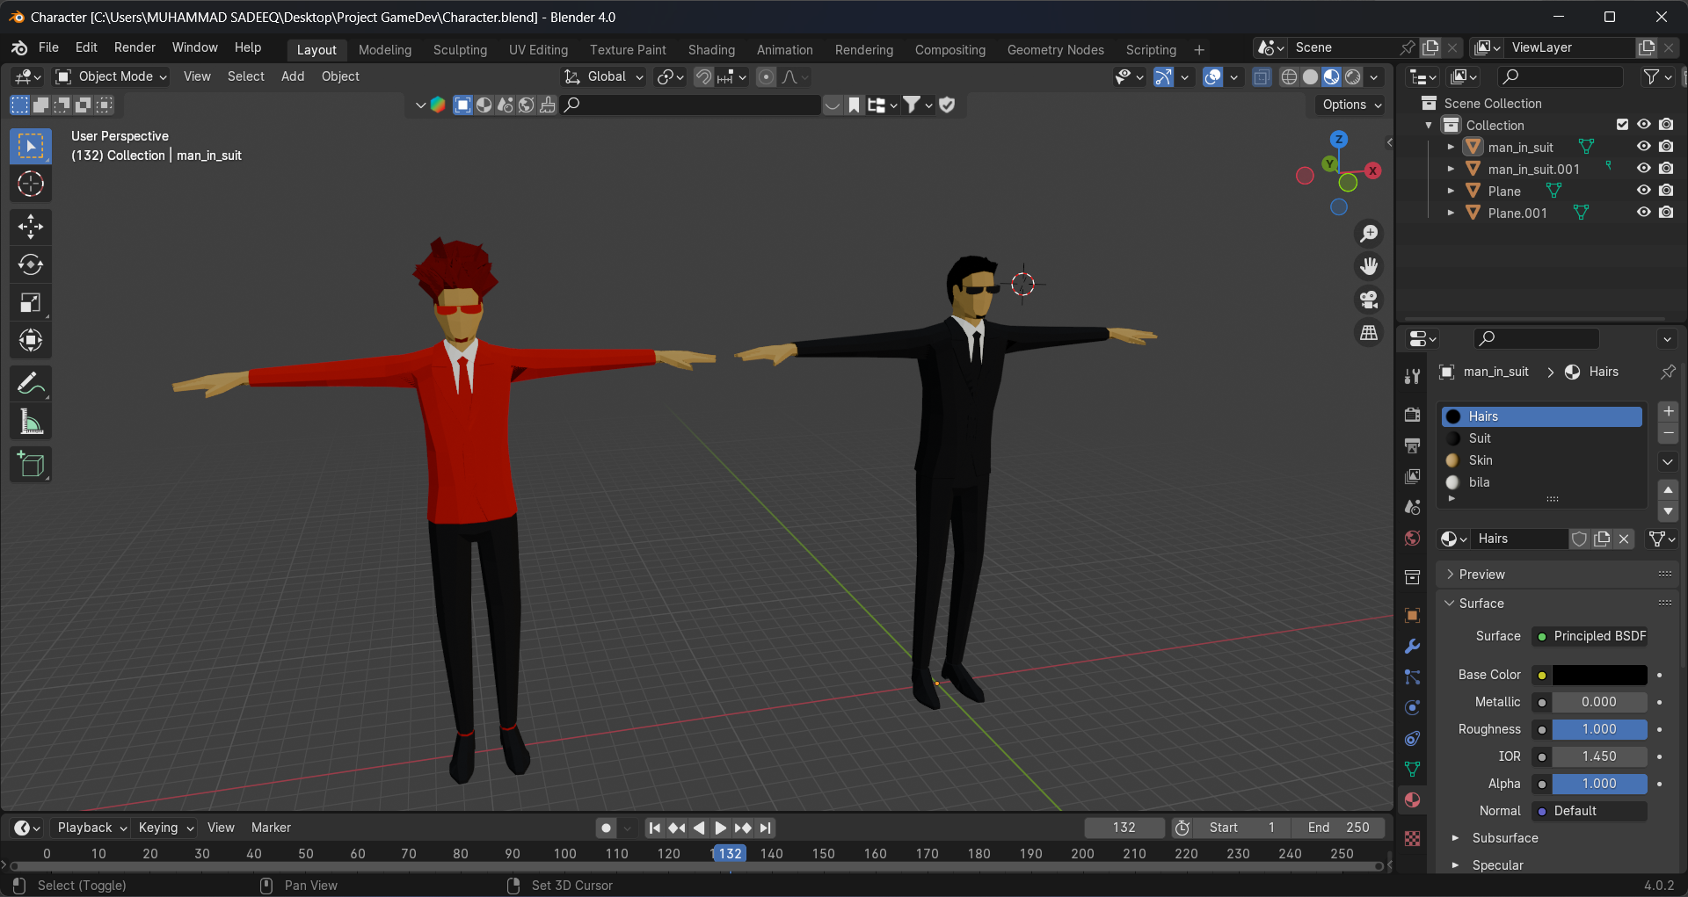

**3. Weapons & Items**

* **Weapons:** Modeled guns, other weapons based on game requirements.
* **Collectibles:** Designed gun boxes, and other collectible items.

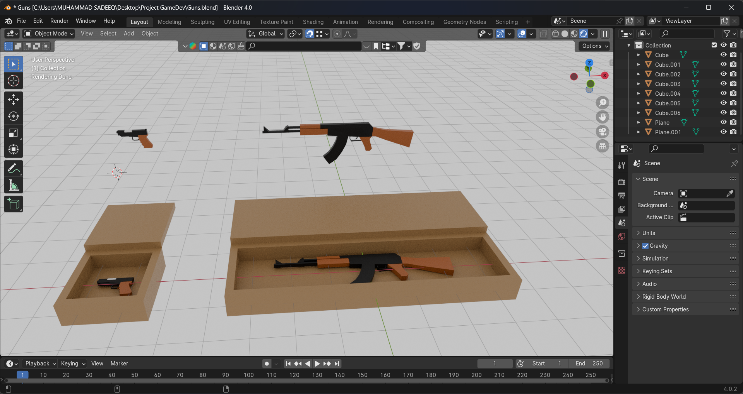

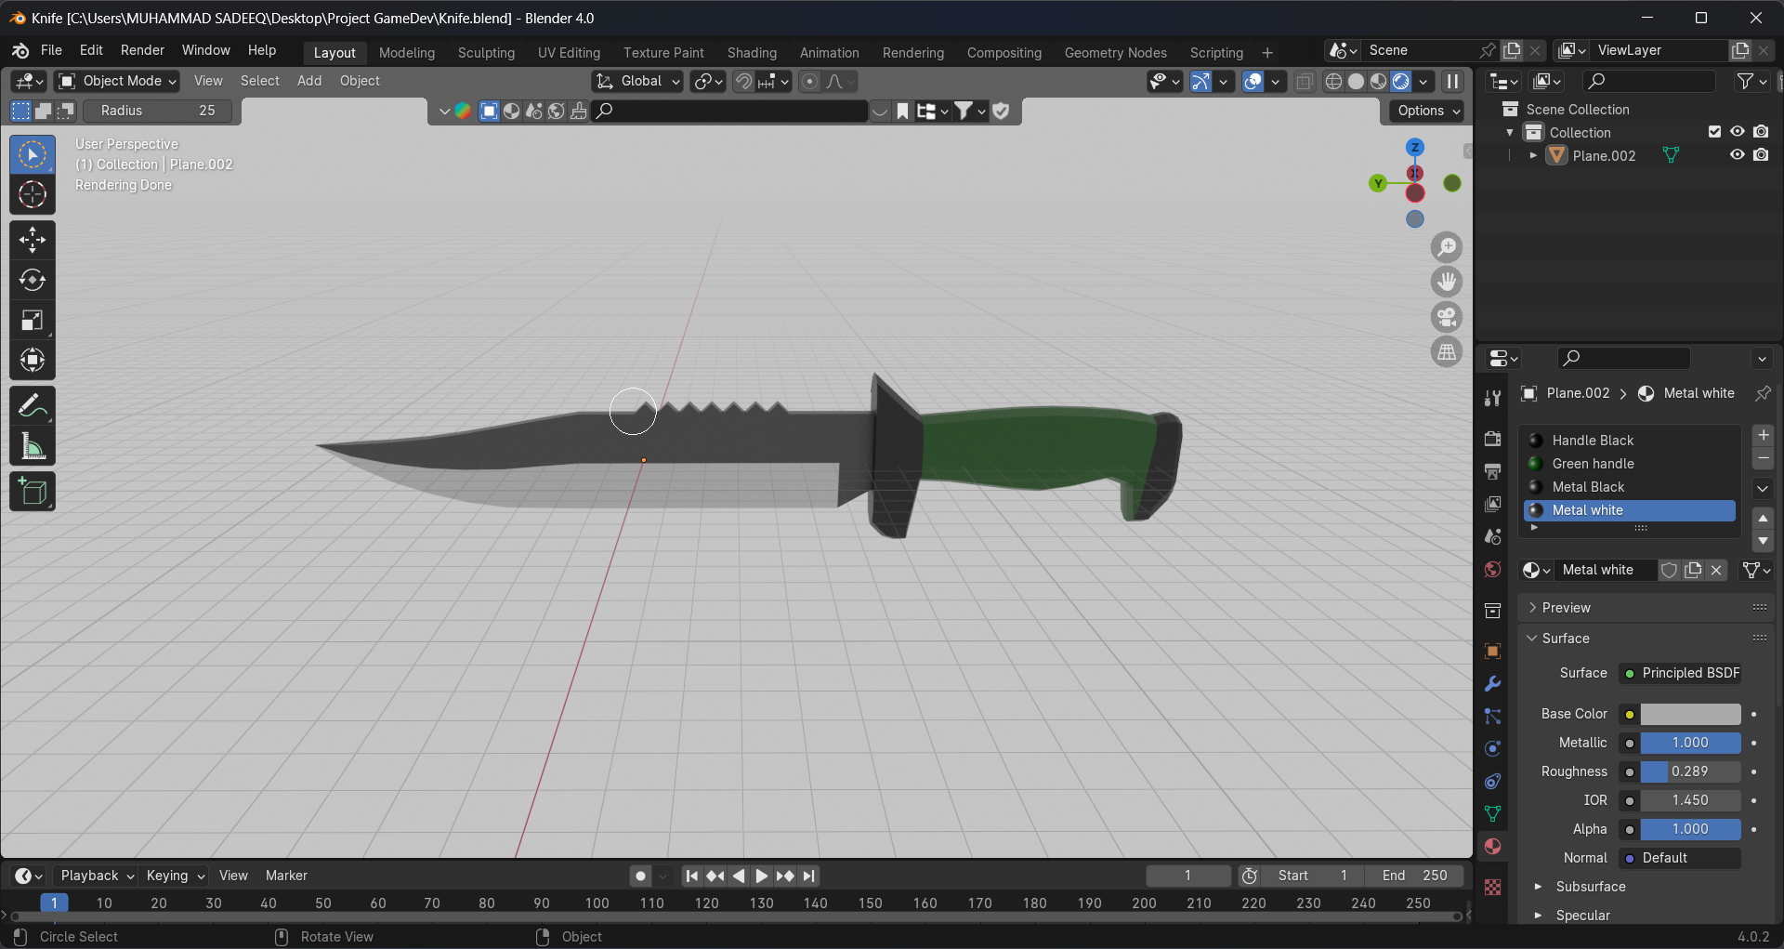

**Tools & Software Used**

* **Blender:** 3D modeling, texturing, and UV unwrapping.
* **Unity 3D:** Integration of 3D assets into the game.
* **Maximo :** For rigging the characters

**Challenges & Solutions**

* **Challenge:** High-poly models affected performance.
  + **Solution:** I made low-poly asset
* **Challenge:** Texture misalignment issues.
  + **Solution:** Proper UV unwrapping and texture mapping.
* **Challenge:** Importing models with animations.
  + **Solution:** Ensured correct rigging and exported models in FBX format for seamless Unity integration.